Db2U Next Gen and the Kubernetes ecosystem
Db2U Next Generation (Next Gen) is a modernized version of the Db2 Universal Operator designed for deploying Db2 and Db2 Warehouse on OpenShift or Kubernetes. It replaces the legacy Operator Lifecycle Manager (OLM) with a Helm-based GitOps-compatible installation model, offering a streamlined experience that better aligns with Kubernetes-native deployment practices.

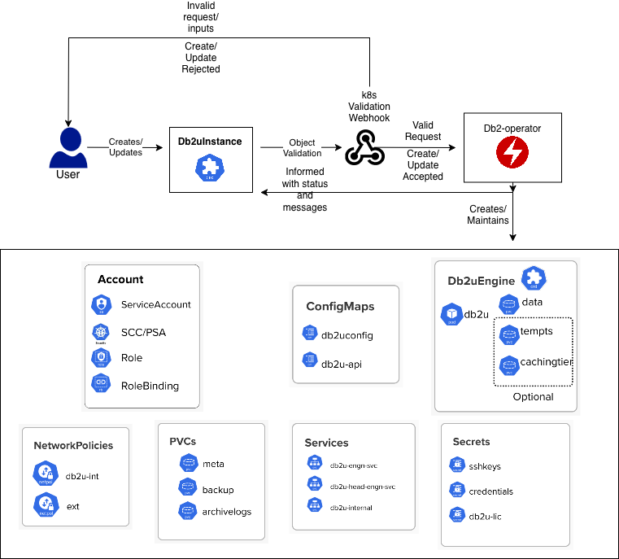

How Db2U Next Gen Transforms the Way DBAs Manage Databases on Kubernetes

Rather than treating Kubernetes as an “application platform” separate from the database layer, Next Gen makes Db2 a first-class Kubernetes resource.
This aligns Db2 with the same operational model used by modern platforms such as PostgreSQL Operators, MongoDB Atlas Operator, and CockroachDB.
Some major benefits of using next gen Db2U are the following:

1. Simplified Installation with Helm

Next gen operator is installed via Helm, giving DBAs a predictable, repeatable, version-controlled installation that aligns with modern Kubernetes tooling and workflows and is GitOps compatible out of the box.

2. Faster, More Efficient Deployments

Spinning up new database environments becomes significantly quicker.While declarative CRDs aren’t new, Db2U Next Gen speeds up provisioning by redesigning the operator’s resource model and reconciliation logic. Fewer Kubernetes objects, lighter reconcilers, and a streamlined create-or-patch workflow mean fewer API calls and faster startup. This leads to quicker, more consistent environment bring-up across clusters.

3. Improved Usability Through Kubernetes Admission Webhooks
The validation webhook is a Kubernetes admission controller that intercepts requests to the API server before they are persisted. It validates incoming requests and rejects those that do not meet predefined criteria. This mechanism helps enforce policies and ensures that only valid resources are created or updated in the cluster.

4. Enhanced Security

Db2U Next Gen strengthens security by adopting a Kubernetes-native model with reduced ClusterRole privileges and the option to bring your own SCCs, service accounts, and RBAC policies. The architecture uses fewer container images, shrinking the attack surface and simplifying vulnerability management. It also integrates cleanly with Kubernetes certificate managers and enterprise identity providers, making secure authentication and certificate handling more consistent across environments

5. Increased HA via Kubernetes Probes and Lightweight Process Management
High availability is delivered using native Kubernetes liveness/readiness probes and a lightweight runit process manager within Db2 pods. This results in faster failure detection, predictable recovery behavior, and fewer moving parts compared to earlier architectures.
This is not “Db2 on Kubernetes/Openshift”. It is Db2 for Kubernetes/Openshift.

Deep Dive: Kubernetes-Native Components in Db2U Next Gen
Below is a breakdown of the major architectural improvements that matter to database platform engineers.
- Helm-Installed Operator
Helm is Kubernetes’ native package manager and provides a structured, repeatable way to deploy complex applications. Instead of handcrafting YAML for CRDs, RBAC, Deployments, webhooks, and configuration objects, Helm bundles everything into a single, versioned chart. For database teams, this means the Db2U Operator can be installed, upgraded, or rolled back with one command, while all environment-specific settings—namespaces, image tags, resource limits, security parameters—are captured in a single values.yaml file. This dramatically reduces manual setup and ensures consistent deployments across clusters. If you want to learn more about Helm’s architecture, you can read further here: https://helm.sh/docs/topics/architecture/
Db2U Next Generation adopts Helm as its installation method, replacing the older OLM-based approach with a cleaner, fully declarative workflow. This shift brings predictable versioning, simpler upgrades, and seamless integration with GitOps tools such as ArgoCD and Flux. As a result, Db2 operator installation becomes well-aligned with modern CI/CD pipelines, making the database lifecycle as automated and reproducible as any other cloud-native component.
Cluster administrators install the operator using a straightforward helm install command, while environment-specific settings are supplied through an overrides.yaml file. This keeps deployments consistent across clusters and makes version control simple. For example:
helm install db2-operator ./db2-operator -f overrides.yaml --set image.tag=0.1
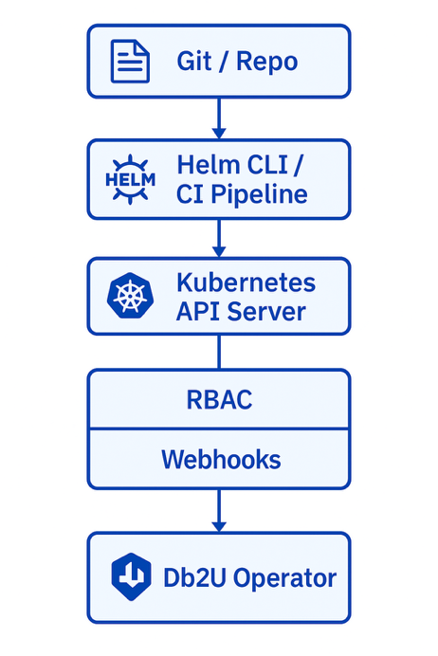
- Admission Webhooks: Validation and Mutation

Kubernetes has a built-in mechanism called admission control, which allows the platform to inspect and evaluate API requests before they persisted into etcd. Admission controllers can modify a request, approve it, or block it entirely. Two of the most powerful mechanisms in this system are MutatingAdmissionWebhooks and ValidatingAdmissionWebhooks.

Mutating Webhooks – Adjusting or Enriching Requests
A mutating webhook can modify an object as it is being created or updated. This When an API request comes in (e.g., creating a Db2uInstance), a mutating webhook can:
- inject default values
- add missing labels or annotations
- fill in implied configuration
- rewrite fields that must conform to operator conventions
This is extremely useful for database CRDs because it reduces the amount of configuration users must specify and ensures consistent baseline settings across deployments.

Validating Webhooks – Enforcing Policy & Preventing Misconfiguration
A validating webhook cannot modify anything — instead, it acts as a gatekeeper. It evaluates the resource after mutation and after schema validation, but before the object is stored in etcd.
Validating webhooks are used to enforce rules such as:
- ensuring required fields follow a specific format
- checking that images come from trusted registries
- blocking configurations that would cause downtime or cluster issues, unless explicitly agreed upon
- validating semantic version compatibility
- preventing unsupported topologies or resource shapes

If the resource fails any rule, the webhook simply returns a rejection and the API request is aborted, and error message is returned to the kubectl/oc command invocation which initiated this request.

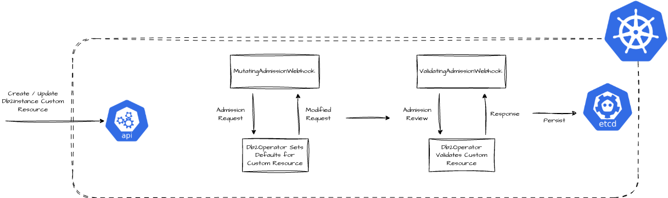

How Db2U Next Gen Leverages Webhooks
The Db2u validation webhook is used to enforce certain policies on the Db2uInstance custom resource. This includes the following policies:
- The Db2uInstance Custom Resource (CR) must have a valid image
The webhook checks the Db2uInstance CR to ensure that the image specified in the spec.image field is valid for the particular operator version. If the image is not valid, for example if it violates the semantic versioning scheme, the webhook will reject the request.
The webhook also rejects any image that is not from the icr.io registry. This is to ensure that only images from the IBM Container Registry are used in the cluster. However, for air-gapped deployments, this can be bypassed by setting the imageRegistryOverride config in the Db2uInstance CR.
- The Db2uInstance CR must be annotated to allow changes that cause downtime
The webhook looks for the maintenance annotation in the CR: db2u.databases.ibm.com/maintenance: "true". It only allows changes that cause a downtime if the annotation is present. The flow for this process is as follows:
- If the annotation is present: the webhook allows changes that cause downtime. For example, scale up/down, cpu/memory changes or update/upgrade, and restore.
- If the annotation is not present, but the changes can be done online, for example labels or annotations: the webhook allows the changes.
- Changes to db and dbm config variables will only be allowed via ADMIN_CMD post CR creation
The webhook checks the Db2uInstance CR to ensure that changes to the db and dbm variables are only allowed on CR creation. Any changes to these variables after CR creation must be done through the ADMIN_CMD procedure. This provides a more consistent experience to native Db2 externals.

- Other user-provided settings in the CR
For example, validating the items array that defines required certificates in the secret when SSL is enabled in the CR.

- A Smarter, Kubernetes-Aligned Operator Architecture
At the heart of every Kubernetes operator is its reconciler — the control loop responsible for driving actual cluster state toward the desired state expressed in a Custom Resource (CR). Db2U Next Generation significantly modernizes this area by replacing heavyweight logic with lightweight, modular, Kubernetes-native reconcilers that are easier to reason about, faster to execute, and more reliable under real-world operational load.

Lightweight Resource Reconcilers: Simple, Fast, Kubernetes-Native
Instead of maintaining complex orchestration code, Db2U Next Gen introduces a set of lightweight reconcilers, each focused on a specific Kubernetes resource (Deployment, Db2uEngine, Service, ConfigMap, Secret, PVC, etc.).
Each reconciler follows a clean, predictable pattern:
- Detect whether the resource exists
- Compare actual state vs desired state
- If needed → patch/update
- If missing → create it
- If no changes → no action taken

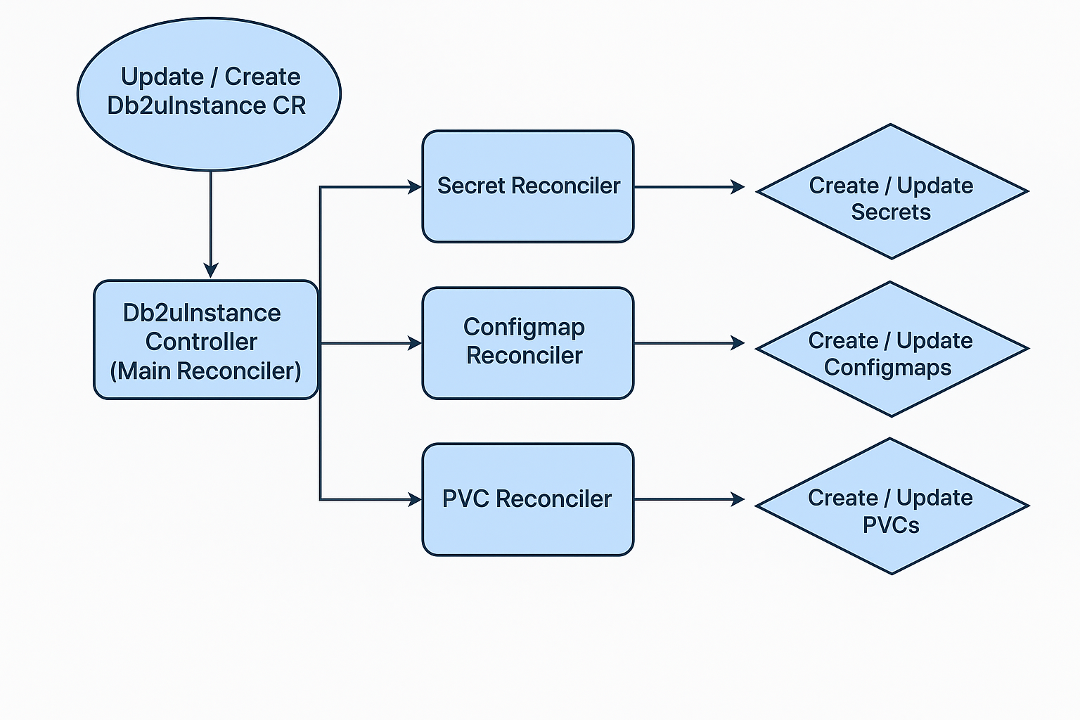

This model is intentionally minimal: no imperative workflows, no hidden side effects, no multi-step orchestration baked into a single giant controller. Instead, each resource reconciler is idempotent, stateless, and easy to debug — perfectly aligned with Kubernetes design principles.

Phase-Driven Main Instance Reconciler
Beyond individual resources, Db2U Next Gen also restructures the main Db2 instance reconciler into clearly defined phases. This is a major departure from traditional monolithic reconciliation loops that attempt to handle all logic in one pass.
The Db2U Instance Reconciler is now divided into phases like:
- Converge Phase
Ensures all underlying Kubernetes primitives (pods, PVCs, services, etc.) match the desired configuration.
- Scale Phase
Triggered when the user adjusts CPU/Memory in the CR. The operator reconciler gracefully terminates the existing pods and brings up new pods with the updated configuration applied.
- Feature Enablement Phase
For toggling or enabling new Db2 feature sets, memory classes, warehouse capabilities, or optional lifecycle behaviors.
- Update / Upgrade Phase
Activated only when the image tag or version-related fields change.
Ensures semantic-versioning rules and safety checks are met before proceeding.
Each phase is only executed when the user initiates a relevant change to the Custom Resource.
This leads to several operational benefits:
- No unnecessary work during reconciles — the operator doesn’t run expensive logic unless the CR requests it.
- Reduced cluster noise — fewer API calls, less churn, fewer failed events.
- Predictable operator behavior — phases act like event-driven workflows rather than a generic infinite loop.
- Safer lifecycle operations — upgrades and scaling are explicitly gated behind user-initiated changes.

Clear Phase Visibility and Better User Experience Through Status & Logs
Another major enhancement in Db2U Next Gen is the improved observability of the reconcile process. Every phase—whether converge, scale, feature enablement, or update/upgrade—is explicitly surfaced both in the operator logs and inside the status field of the Db2uInstance CR. This gives users immediate clarity on what the operator is doing and why. Instead of opaque or monolithic reconcile loops, the operator now reports fine-grained status messages such as the active phase, progress markers, pending operations, or validation failures. As a result, misconfigurations, blocked upgrades, missing resources, or dependency failures become significantly easier to detect. For DBAs and Kubernetes operators, this leads to faster troubleshooting, fewer support calls, and an overall smoother operational experience—because the operator “tells you what it’s doing” instead of silently attempting to correct state behind the scenes.

- Storage Pre-checker: Ensuring Storage Readiness for Db2 Workloads
When running a stateful database on Kubernetes (or OpenShift), properly configured storage is critical. Persistent storage must meet certain requirements — correct access modes, proper permissions, and more — otherwise you risk data corruption, misbehavior, or failed deployments.

To avoid these risks, Db2U Next Gen introduces a “Storage Pre-checker” — a mechanism that validates storage configuration before the database engine starts.

Typical checks and validations include:
- Filesystem permissions, mount options, and SELinux/security context
The pre-checker validates that the mounted volume provides Db2 with the correct read/write permissions and compatible security context. This prevents issues where Db2 cannot initialize directories, write logs, or create metadata due to restrictive storage permissions.
- Storage performance / speed checks
Db2 has minimum throughput and latency requirements for its data directories, transaction logs, and temporary spaces. The pre-checker measures basic storage I/O characteristics to ensure that the underlying storage meets the minimum performance thresholds needed for Db2 to operate reliably. If the volume is too slow or inconsistent, the pre-checker will fail early rather than allowing Db2 to start on inadequate storage.
- Verification that storage can meet Db2’s minimum operational requirements
Beyond raw speed, the pre-checker ensures that the allocated storage configuration (filesystem type, mount stability, provisioning behavior, capacity, etc.) is consistent with what Db2 expects. This prevents scenarios where Db2 pods start successfully but fail later because the filesystem cannot sustain normal DB workloads.

How Pre-checker Enhances Reliability, Safety, and DBA Experience

• Prevents “half-deployed” or “broken storage” databases
Because the pre-checker validates storage before Db2 starts, the risk of ending up with partially initialized databases hanging in wrongly configured storage drops dramatically. Instead of discovering errors when the database boots (or worse, later during runtime), those errors surface early — during deployment.

• Saves time and reduces operational uncertainty
For DBAs, verifying storage manually (type, compatibility, permissions, access mode, etc.) can be tedious and error-prone — especially across different clusters or environments. The pre-checker automates this validation, making deployment repeatable, reliable, and less stressful.

• Provides clear feedback — in CR status & logs
When a pre-checker error occurs, it logs details (and in so doing helps in troubleshooting), and reports them in the status section of the Db2uInstance CR. This makes it easier for teams to understand what went wrong — storage misconfiguration rather than, say, Pod or network failure.

• Makes Db2 on Kubernetes more production-ready
While Kubernetes’ native storage abstractions (PersistentVolumes, PersistentVolumeClaims, StorageClasses) are powerful, they are also flexible — which means misconfiguration is easy. By embedding a pre-checker, Next Gen reduces the barrier for running Db2 reliably in a containerized, Kubernetes-native way.

- Simplifying SSL/TLS in Db2U Next Gen Through cert-manager Integration

Why TLS / Cert Management Matters
In many enterprise and cloud-native environments, databases must support encrypted connections (TLS) — especially if clients are remote, or if traffic passes untrusted networks. Managing TLS manually (issuing certs, rotating, distributing secrets) is error-prone and operationally heavy.
Using a Kubernetes-native certificate management solution like cert-manager lets you automate certificate issuance, rotation, and renewal, while integrating with CR-driven workflows. This drastically reduces manual overhead and improves security hygiene.

What Is cert-manager and How It Works with Db2U Next Gen
- cert-manager is a Kubernetes-native tool that leverages CustomResourceDefinitions (CRDs) to define certificate requests (Certificate, Issuer, ClusterIssuer, etc.).
- Once installed in your cluster (typically via Helm or YAML manifests), cert-manager watches for Certificate resources, issues signed certificates (via self-signed CA, or via ACME/Let’s Encrypt, or via internal CA), stores them as Kubernetes Secrets, and automatically renews them when close to expiration. More information about cert manager can be found here - https://cert-manager.io/v1.1-docs/installation/kubernetes/
- For Db2U Next Gen: when you configure a Db2uInstance CR, there is support for TLS/SSL in the spec. This means it’s possible (and recommended) to supply a Kubernetes Secret containing tls.crt and tls.key, referencing a certificate managed by cert-manager.
- As a result, database clients can connect to the Db2 instance over TLS, with the certificate trust chain handled by Kubernetes / cert-manager, rather than manually distributing certs.

Automatic Certificate Renewal and Online TLS Updates
One of the key advantages of using cert-manager with Db2U Next Gen is that certificate lifecycle management becomes fully automated. cert-manager continuously monitors certificate expiration and renews the TLS secret before it becomes invalid. Db2U Next Gen extends this workflow through an SSL informer integrated into its phase-based reconciler. The informer watches for changes to the certificate Secret—such as a renewal event—and automatically triggers the appropriate TLS update phase inside the Db2 instance. This enables Db2 to refresh its TLS configuration online, without requiring disruptive restarts or manual intervention. The combination of cert-manager’s automated renewal and the operator’s SSL-aware reconciliation delivers a seamless, Kubernetes-native approach to maintaining secure connections throughout the database lifecycle.

Conclusion
Db2U Next Generation brings Db2 closer to the Kubernetes ecosystem than ever before. With improvements across installation, governance, reconciliation, and storage validation, the platform now reflects the expectations of modern cloud-native operations. The result is a database that is easier to deploy, safer to operate, and better aligned with GitOps workflows and enterprise automation strategies. For teams standardizing on Kubernetes, Db2U Next Gen offers a robust and future-ready foundation.

About the Authors

Janpreet Singh Chandhok is a software engineer with in the Db2 containerization offering based in the Toronto lab, with a strong focus on hybrid-cloud technologies, Kubernetes orchestration, and enterprise-grade data systems. He completed his degree in Computer Engineering at the University of Toronto with a minor in Artificial Intelligence, where he developed a deep interest in distributed systems and intelligent automation. He can be reached at janpreet.chandhok@ibm.com

Anant Prakash a software engineer with in the Db2 containerization offering based in the Toronto lab. He is experienced in Software Development with a demonstrated history of working in the information technology and services industry. He is a strong business development professional with a Bachelor of Applied Science - BASc focused in Computer Science from McMaster University. He can be reached at anant@ibm.com
Austin Clifford is a Senior Technical Staff Member in Hybrid Data Management based in the Ireland Lab. He has worked with database, data lake and warehousing technologies for more than two decades. In 2012, Austin led the team to achieve a Guinness World Record for the Largest Data Warehouse, a record that IBM held for two years. Austin has authored numerous papers and patents, advises clients on data warehouse, analytics and containerization best practices and is a regular speaker at technical conferences. He can be reached at acliffor@ie.ibm.com

